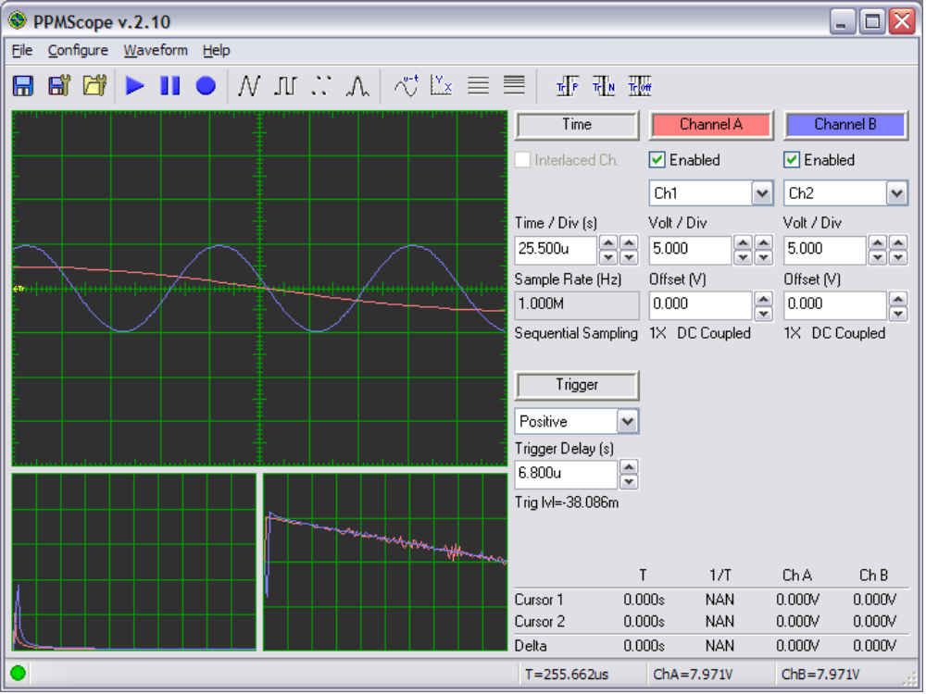
Save Settings
Save Waveform
Open Settings
Capture Modes: Continuous, Single, and Hold
Waveform Reconstruction: Triangle, Square, Point, and Sinc
Time versus Voltage
X-Y Display
Spectrum Linear Scale
Spectrum Logarithmic Scale
Trigger Modes:
Positive, Negative, Off
Main Oscilloscope Screen:
Left Click for Cursors
Drag cursors on and off screen
Display in time versus voltage mode
Display in Spectrum Linear Scale mode
Display in Phase mode
Subordinate Oscilloscope Screens:
Double left click to elevate to main screen
Hardware Connection Indicator
Status Bar Tips
Mouse Over
Time / Frequency Indicator
Mouse Over
Voltage / Phase Indicators
Cursor Measurements Display
Oscilloscope Settings Control Panel with Indicators
Gain and Coupling Indicators
Sampling Rate and Mode Indicators
Trigger Level Indicators

